BRAINWARE UNIVERSITY
PYTHON PROJECT-BASED LEARNING REPORT (WEEK 3)

1. Basic Information
Title of the Project: | Console-Based Management Systems (Programs 1- 3)
Programs Covered: | Program 1: Bank Management System  Program 2: Hotel Booking System  Program 3: Library Management System
Name(s) of Student(s): | Soumyadwip Das (BWU/BTS/25/169)  Ankita Paul (BWU/BTS/25/180)  Sonia Naskar (BWU/BTS/25/195)  Joyeta Mondal (BWU/BTS/25/214)  Sayantan Bharati (BWU/BTS/25/503)
Programme & Semester: | B.Tech CSE & 3rd Semester
Course Name & Code: | Python Programming Lab (BES09013)
Name of the Guide/Supervisor: | MR. PRANAB GHARAI & MR. INDRANIL DAS

2. Introduction and Background

Week 3 focused on three menu-driven Python applications: Bank Management System, Hotel Booking System, and Library Management System. All use in-memory data structures, a common boxed terminal interface, and menu-driven control flow. This report presents each program separately, followed by a combined timeline, tools, and references

3. Program 1: Bank Management System

3.1 Introduction and Background
A Bank Management System simplifies banking operations such as account creation, balance enquiry, deposits, and withdrawals. This project develops a console-based Python application using in-memory data structures, featuring unique account generation, PIN authentication, and a boxed terminal interface.

3.2 Objectives
- Develop a menu-driven bank management system.
- Generate unique account numbers.
- Implement PIN-based authentication.
- Support deposit, withdrawal, and balance enquiry.
- Build a consistent terminal interface.

3.3 Problem Statement / Driving Question
How can basic banking operations be implemented securely in a menu-driven console application using Python without an external database?

3.4 Methodology

Program Design: Created a boxed terminal interface using reusable helper functions and an ASCII-art banner.

Data Structures: Used a USERS dictionary to store account details and an ACCOUNTS list to maintain unique account numbers.

Core Banking Functions: Implemented account generation, account creation, authentication, deposit, and withdrawal with balance validation.

Menu-Driven Control Flow: Built a continuous menu with Create Account, Check Balance, Withdraw, Deposit, and Exit options, along with input validation and error handling.

3.5 Expected Outcomes / Deliverables
- A functional bank management system.
- Unique account number generation.
- Secure PIN-based authentication.
- Input validation and error handling.
- A user-friendly boxed terminal interface
3.6 Core Logic
def generate_account():
while True:
num = math.floor(random.random() * (10 ** 10))
account_no = "A" + str(num)
if account_no not in ACCOUNTS:
return account_no # ensures every account number is unique

def withdraw(account, amount):
if amount <= USERS[account]['balance']:
USERS[account]['balance'] -= amount
return True # withdrawal allowed, balance updated
return False # insufficient funds, transaction rejected
The generate_account() function creates a unique account number by generating a random 10-digit value and ensuring it does not already exist. The withdraw() function allows transactions only when sufficient balance is available, preventing negative account balances.

3.7 Output Screenshot
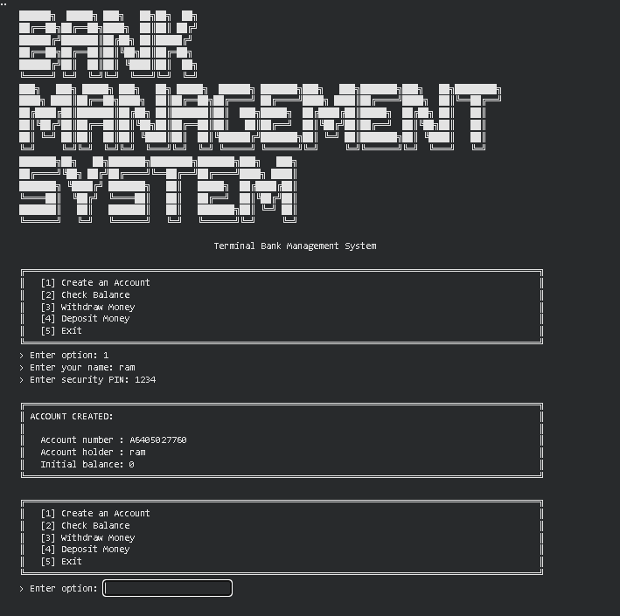

4. Program 2: Hotel Booking System

4.1 Introduction and Background
A Hotel Booking System simplifies room reservation by managing room availability, bookings, and check-outs. This project develops a console-based Python application using in-memory data structures with a consistent boxed terminal interface.

4.2 Objectives
- Develop a menu-driven hotel booking system.
- Manage multiple room categories and availability.
- Generate unique booking IDs.
- Calculate booking cost based on room type and stay duration.
- Support booking, check-out, and booking history.
- Build a consistent terminal interface.

4.3 Problem Statement / Driving Question
How can a hotel manage room availability, bookings, check-outs, and billing using a simple console-based application without an external database?

Methodology

Program Design: Created a boxed terminal interface using reusable helper functions and an ASCII-art banner.

Data Structures: Used ROOM_TYPES to store room details and BOOKINGS to manage reservation records.

Core Booking Functions: Implemented room availability checking, booking creation with unique booking IDs, total cost calculation, and check-out functionality.

Menu-Driven Control Flow: Built a continuous menu with room viewing, booking, check-out, and booking history options, including input validation and error handling.

4.5 Expected Outcomes / Deliverables
- A functional hotel booking system.
- Real-time room availability tracking.
- Unique booking ID generation.
- Accurate booking cost calculation.
- Input validation and error handling.
- A user-friendly boxed terminal interface.

4.6 Core Logic
def available_rooms(room_type):
booked = sum(
1 for b in BOOKINGS.values()
if b["room_type"] == room_type
and b["status"] == "Booked"
)
# vacancy = total rooms - active bookings
return ROOM_TYPES[room_type]["count"] - booked

def book_room(name, room_type, nights):
if available_rooms(room_type) <= 0:
return None, f"No {room_type} rooms available."
booking_id = 1001 + len(BOOKINGS) # unique, sequential
total = ROOM_TYPES[room_type]["price"] * nights
BOOKINGS[booking_id] = {
"name": name, "room_type": room_type,
"nights": nights, "total": total, "status": "Booked"
}
return booking_id, total
The available_rooms() function calculates the number of vacant rooms by subtracting active bookings from the total room count. The book_room() function checks availability, generates a unique booking ID, calculates the total cost, and stores the reservation, ensuring rooms cannot be overbooked.

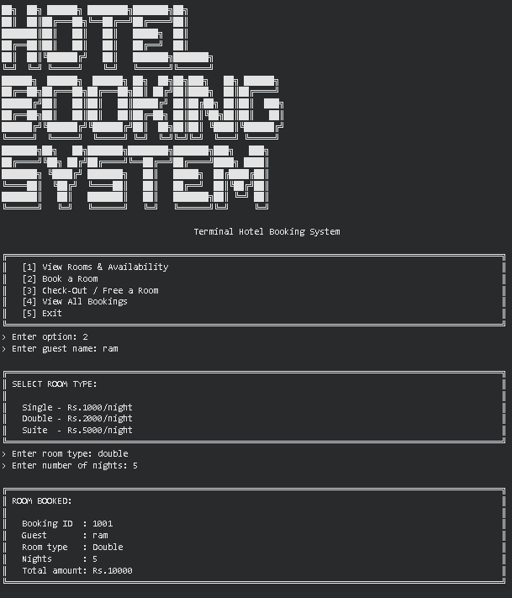
4.7 Output Screenshot

5. Program 3: Library Management System

5.1 Introduction and Background
A Library Management System helps manage book records, availability, and borrowing activities. This project develops a console-based Python application that supports adding, viewing, issuing, returning, and searching books using in-memory data structures and a boxed terminal interface.

5.2 Objectives
- Develop a menu-driven library management system.
- Add and manage book records with unique IDs.
- Support book issue and return operations.
- Search books by ID, title, or author.
- Display book records and availability.
- Prevent invalid issue and return operations.

5.3 Problem Statement / Driving Question
How can a console-based application efficiently manage library records while preventing invalid book issue and return operations?

5.4 Methodology
- Program Design: Created a boxed terminal interface with reusable helper functions and an ASCII-art banner.
- Book Record Management: Stored book details in a BOOKS dictionary, implemented duplicate ID validation, and displayed records in a formatted table.
- Issue, Return & Search Logic: Developed functions to issue, return, and search books with proper validation and tested all menu operations.

5.5 Expected Outcomes / Deliverables
- A functional library management system.
- Accurate book issue and return tracking.
- Search functionality for book records.
- A clear, tabular catalogue display.
- Scope for future enhancements such as due dates and persistent storage.

5.6 Core Logic
def issue_book(book_id, member):
# Only an existing, currently-Available book can be issued
if book_id in BOOKS and BOOKS[book_id]["status"] == "Available":
BOOKS[book_id]["status"] = "Issued"
BOOKS[book_id]["issued_to"] = member
return True
return False

def return_book(book_id):
# Only a book currently marked Issued can be returned
if book_id in BOOKS and BOOKS[book_id]["status"] == "Issued":
BOOKS[book_id]["status"] = "Available"
BOOKS[book_id]["issued_to"] = ""
return True
return False

The issue_book() and return_book() functions update a book's status only when the requested action is valid, ensuring a book cannot be issued twice or returned before being issued.

5.7 Output Screenshot
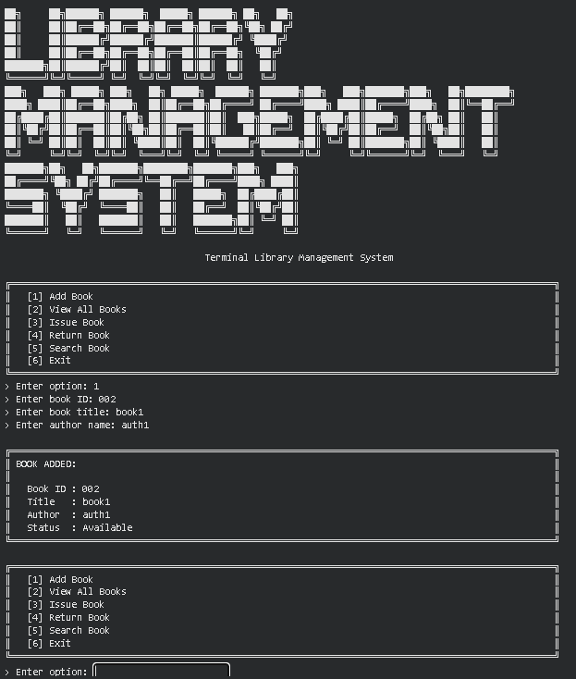

6. Tools & Technologies Used
Tool / Technology | Purpose
Python 3.x | Core programming language
Dictionary & List | Store accounts, bookings, and book records
random & math Modules | Generate unique account numbers
f-Strings | Format console output
Command-Line Interface | Run and test the applications
Text Editor / IDE | Develop and debug the programs

7. References
- Python Official Documentation
- Python Dictionaries Documentation
- Python random & math Module Documentation
- Python String Formatting Documentation
- GeeksforGeeks – Python Management System Tutorials
- Brainware University – Python Programming Lab Course Guidelines

8. Signatures
Signature of Student(s): Date of Submission:

Signature of Guide/Supervisor:

